**Tutorial 1**

1. Perform SVM on irisexcel.csv and predict species for: Trial 1: [3.7, 4.9, 5.2, 3.3] (Common to all)

Trial 2: Roll no 1: [2.5, 3.8, 4.6, 5.2]

**CODE:**

**Trial 1**

#1.Training

#Load data

import pandas as pd

iris = pd.read_csv("/content/irisexcel.csv")

x=iris[['sepal_length','sepal_width','petal_length','petal_width']]

y=iris['species']

#algo

from sklearn.svm import SVC

Model=SVC()

#fit data

ML= Model.fit(x,y)

#2.Testing

Result=ML.predict([[3.7,4.9,5.2,3.3]])

print (Result)

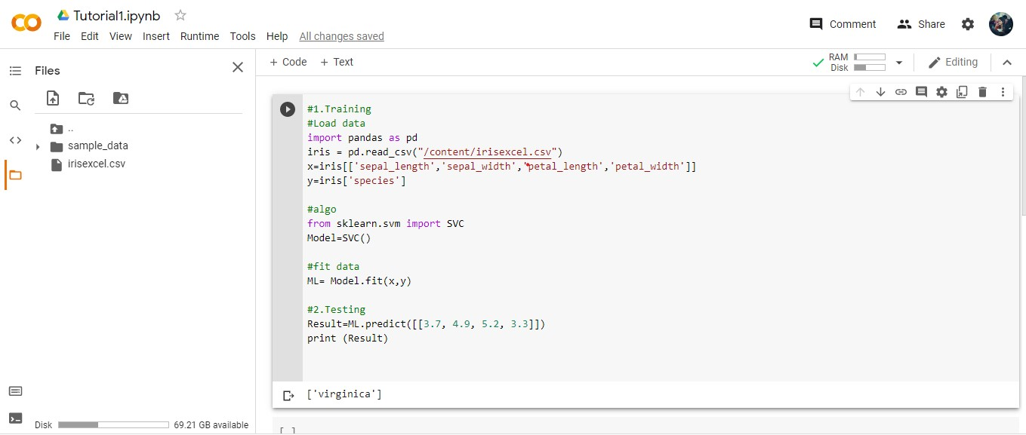

**Trial 2**

#1.Training

#Load data

import pandas as pd

iris = pd.read_csv("/content/irisexcel.csv")

x=iris[['sepal_length','sepal_width','petal_length','petal_width']]

y=iris['species']

#algo

from sklearn.svm import SVC

Model=SVC()

#fit data

ML= Model.fit(x,y)

#2.Testing

Trial2=ML.predict([[2.5, 3.8, 4.6, 5.2]])

print (Trial2)

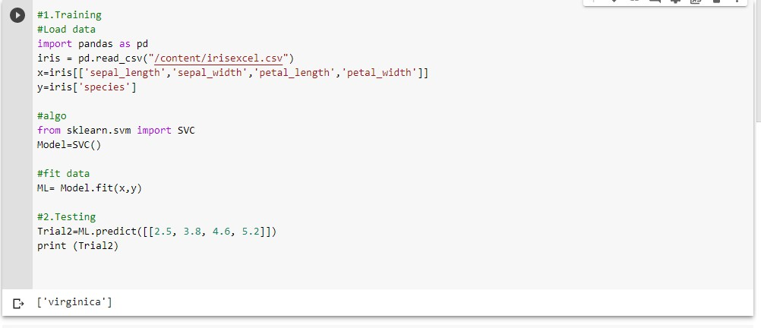

1. Justify your observations in Difference between your Trial 1 & Trial 2 Results. (You may attach a notepad file)

In both trial 1 and trial 2, got the same result ‘Virginica’, as it has similar features values during testing, so grouped into same species ie; by using SVM we can classify the species in to groups with respect to the feature values used to train the model.